BASIC UNDERSTANDING ON FREE AND OPEN-SOURCE SOFTWARE

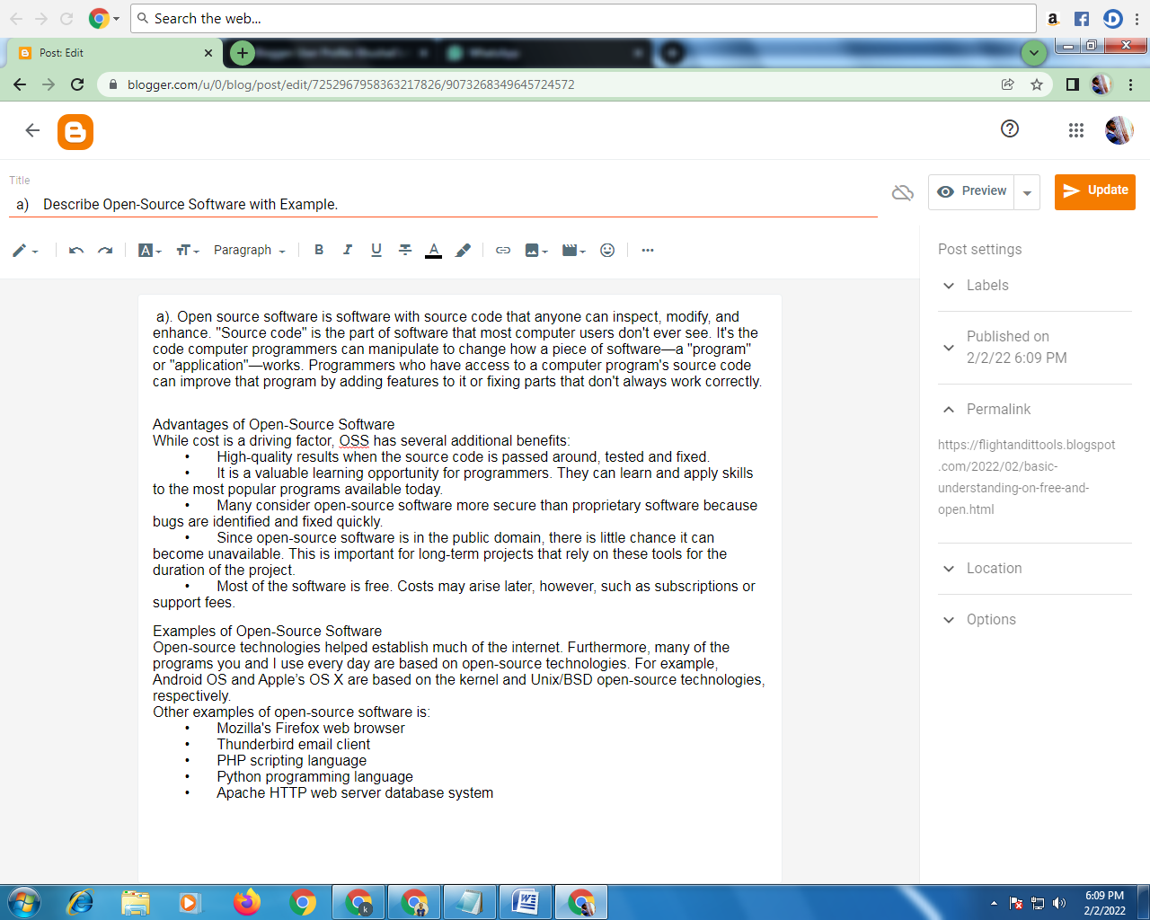

a)Describe Open-Source Software with Example.

Open source software is software with source code that anyone can inspect, modify, and enhance.

"Source code" is the part of software that most computer users don't ever see. It's the code computer programmers can manipulate to change how a piece of software—a "program" or "application"—works. Programmers who have access to a computer program's source code can improve that program by adding features to it or fixing parts that don't always work correctly.

Advantages of Open-Source Software

While cost is a driving factor, OSS has several additional benefits:

• High-quality results when the source code is passed around, tested and fixed.

• It is a valuable learning opportunity for programmers. They can learn and apply skills to the most popular programs available today.

• Many consider open-source software more secure than proprietary software because bugs are identified and fixed quickly.

• Since open-source software is in the public domain, there is little chance it can become unavailable. This is important for long-term projects that rely on these tools for the duration of the project.

• Most of the software is free. Costs may arise later, however, such as subscriptions or support fees.

Examples of Open-Source Software

Open-source technologies helped establish much of the internet. Furthermore, many of the programs you and I use every day are based on open-source technologies. For example, Android OS and Apple’s OS X are based on the kernel and Unix/BSD open-source technologies, respectively.

Other examples of open-source software are:

• Mozilla's Firefox web browser

• Thunderbird email client

• PHP scripting language

• Python programming language

• Apache HTTP web server database system

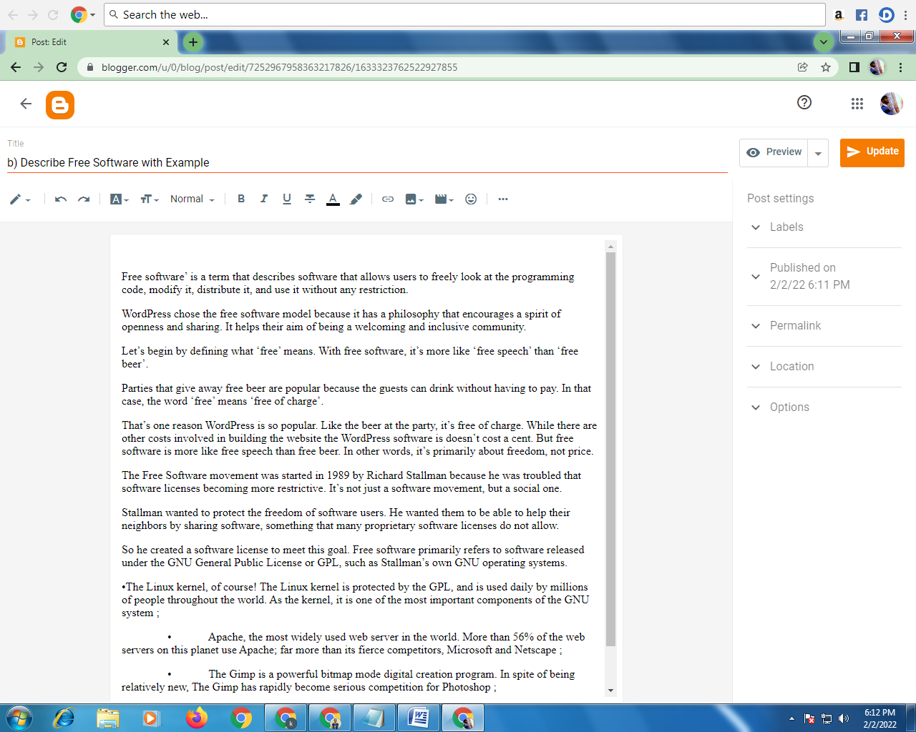

b) Describe Free Software with Example

Free software’ is a term that describes software that allows users to freely look at the programming code, modify it, distribute it, and use it without any restriction.

WordPress chose the free software model because it has a philosophy that encourages a spirit of openness and sharing. It helps their aim of being a welcoming and inclusive community.

Let’s begin by defining what ‘free’ means. With free software, it’s more like ‘free speech’ than ‘free beer’.

Parties that give away free beer are popular because the guests can drink without having to pay. In that case, the word ‘free’ means ‘free of charge’.

That’s one reason WordPress is so popular. Like the beer at the party, it’s free of charge. While there are other costs involved in building the website the WordPress software is doesn’t cost a cent. But free software is more like free speech than free beer. In other words, it’s primarily about freedom, not price.

The Free Software movement was started in 1989 by Richard Stallman because he was troubled that software licenses becoming more restrictive. It’s not just a software movement, but a social one.

Stallman wanted to protect the freedom of software users. He wanted them to be able to help their neighbors by sharing software, something that many proprietary software licenses do not allow.

So he created a software license to meet this goal. Free software primarily refers to software released under the GNU General Public License or GPL, such as Stallman’s own GNU operating systems.

•The Linux kernel, of course! The Linux kernel is protected by the GPL, and is used daily by millions of people throughout the world. As the kernel, it is one of the most important components of the GNU system ;

• Apache, the most widely used web server in the world. More than 56% of the web servers on this planet use Apache; far more than its fierce competitors, Microsoft and Netscape ;

• The Gimp is a powerful bitmap mode digital creation program. In spite of being relatively new, The Gimp has rapidly become serious competition for Photoshop ;

• PostgreSQL is an object-relational database. It is currently the most sophisticated free software database available.

c)Difference between Free and Open-Source Softwar 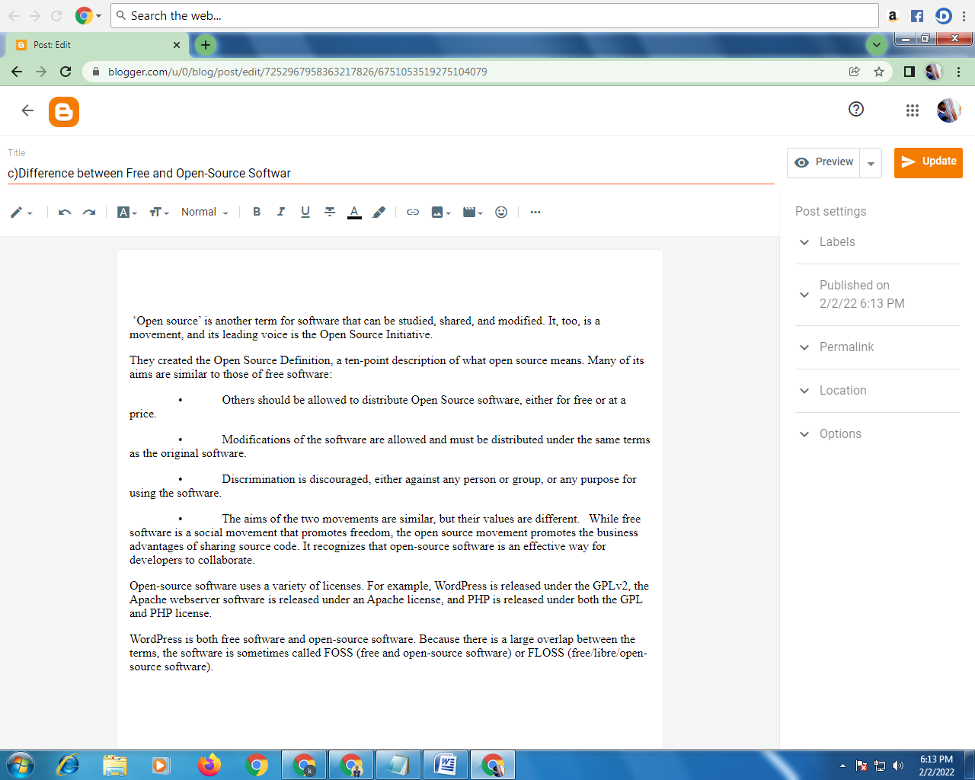

‘Open source’ is another term for software that can be studied, shared, and modified. It, too, is a movement, and its leading voice is the Open Source Initiative.

They created the Open Source Definition, a ten-point description of what open source means. Many of its aims are similar to those of free software:

• Others should be allowed to distribute Open Source software, either for free or at a price.

• Modifications of the software are allowed and must be distributed under the same terms as the original software.

• Discrimination is discouraged, either against any person or group, or any purpose for using the software.

• The aims of the two movements are similar, but their values are different. While free software is a social movement that promotes freedom, the open source movement promotes the business advantages of sharing source code. It recognizes that open-source software is an effective way for developers to collaborate.

Open-source software uses a variety of licenses. For example, WordPress is released under the GPLv2, the Apache webserver software is released under an Apache license, and PHP is released under both the GPL and PHP license.

WordPress is both free software and open-source software. Because there is a large overlap between the terms, the software is sometimes called FOSS (free and open-source software) or FLOSS (free/libre/open-source software).